13.3.1 Editors - Video Sequence Editor - Sidebar - Preview - Tool tab
Tool Tab 1
Active Tool panel 1
Metadata Panel 1

Tool Tab

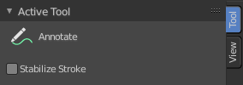
In the tool tab you will find the tool related settings for the tools in the tool shelf.

Active Tool panel
Displays the settings for the tools in the tool shelf. These settings are explained in the tool shelf chapters.

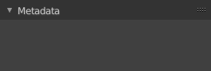
Metadata Panel
Displays existing metadata of the strip content.

